- Завдання з англійської мови для студентів І курсів ХОМ, ХК, ХТ, ХВ, ХОД:
- Підручник Верба: Перфектні часи повторити, зробити конспект , виконати вправи письмово: 99,100, 101,105,106,107, 108,110, 111, 112.
- Написати твір на тему"What is the role of computers in modern life"
(Do you think computers help society?
Do you think computers are bad for health?
What are the advantages and disadvantage sof the Internet?
What do you usually do on the Internet?
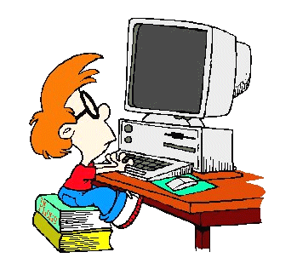Слова записати у словники і перекласти:
MY COMPUTER
  The hardware
  A computer
  A laptop
  The central processing unit
  A screen
  A monitor
  A keyboard
  A key
  A mouse
  A mouse pad
  A printer
  A scanner
  A floppy disk
  The hard disk
  The CD drive
  The disk drive
  A modem
 | ON THE SCREEN  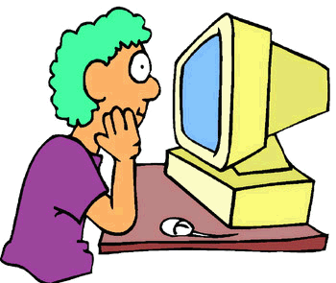
  A window
  A page
  The cursor
  The password
  A program
  A file
  The file menu
  A directory
  A database
  System files
  A software program
  A shortcut
  The trash
  clipboard
  To open / to close
  To click
  To select (all)
  To install
  To start a program
  To program
  To delete a file
  To insert
  To copy
  To paste
  To cut
  To delete
  To save / to save as
  To print
  To scan
  To computerize
THE INTERNET  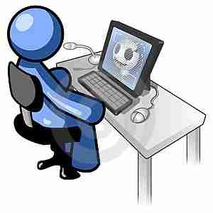
  A Net surfer
  Network
  An internet service provider (ISP)
  A search engine
  a browser
  A server
  A login
  A link
  A Website
  A webmaster
  A Webpage
  A homepage
  The Internet
  To get on line
  To log on a website
  To exit
  To be on line
  To be off line
  To download
 | EMAILS  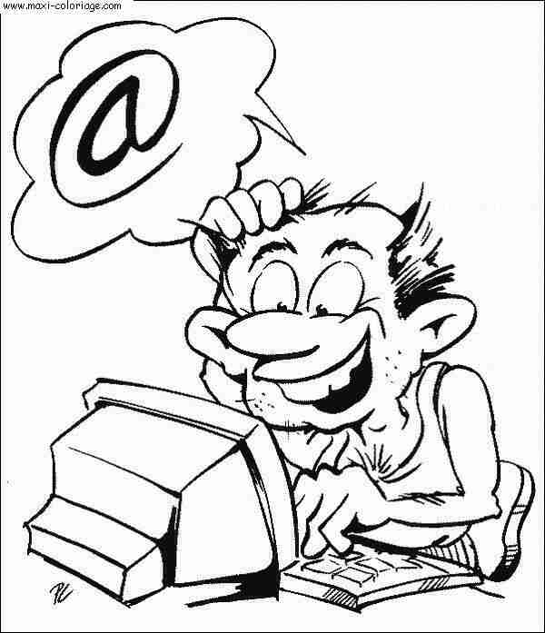
  The mail box
  Inbox
  An e-mail account
  An e-mail address
  At/At sign
  Directory
  To e-mail / to send an e-mail
  To forward / To send on
  To write a message
  To answer a message

- 
@ | at
.com | dot com …
_ | underscore
/ | slash

- Виконати тести:
- Начало формы
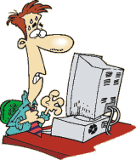 I bought my yesterday but I can't use it. I can't use my software. In the manual, it was written : 'easy to ' !
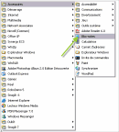 If you want this text to be , you'd better it into your clipboard. the main , search the function 'Save to clipboard' in your and on it. Then your text into your new document.
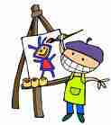 My picture is pretty good! I am going to it and publish it on my blog.
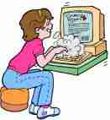 My is full: there are too many from Nadine. I must , but her was when my computer crashed and I can't remember it.
 Thank you for giving me your email address. My address is 'tom_smiths@myprovider.com' not in capitals.
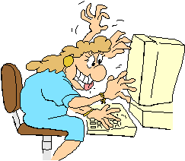 I've just joined this new site. I am but I am trying to find on the where I can .Perhaps I should contact the !
Тексти для читання:
«Computers in our life»
Nowadays computers have become an extremely important part of our life. They are used by children and old people, both for fun, for studying and for work. As for me, personal computer is a great invention. However, as every invention it also has both drawbacks and advantages.
Firstly, computers make our life easier. In every modern office there are computers to help people work faster. Students and schoolchildren use computers for studying. For example, the can find information for reviews or essays in the Internet. Secondly, computer is a tool for fun and communication. With the help of the Internet people from different corners of the world can communicate easily, developing international relationships. When we are bored, we can play online games with others or watch a movie using our PC.
On the other hand, spending much time working on a computer, we can damage our health. It also prevents us from walking and enjoying our hobbies. Perhaps, computers sometimes make our life too easy. Solving all the problems, they leave nothing for us to do.
Personally I cannot imagine my life without computers. They are completely necessary in the today’s developing world.
To make a conclusion, I would like to say that computers are great. Our life would be dull and boring without them. However, we should limit the amount of time we spend using them to avoid troubles.
"Computers in our lives
The role of the computer in our lives is currently growing from day to day. It can be explained by the fact that computers help people to do their work much more easily and quickly. Computers can be characterized, as very comfortable, reliable and accurate. The biggest advantage is the price of computers, they are quite cheap. They give people very quick and quality information, so in such a way people don’t have to spend their time, turning leaves of dozens of books. Computers are easy to use, so you don’t have to be a genius to be able to work on it. And even if it is hard for you to learn it, you can buy some videos and books that will help you to do it.
In today's world, computers are used nearly in all branches of industry. Even in that one that are dangerous and harmful to human health. Scientists can’t imagine space research without using computers. Today computers can diagnose very severe illnesses and help to carry out operations.
Using a computer you can search something on the internet. It has many advantages. You can exchange information electronically. The Internet users can enjoy online media and they can help other people to solve their problems. It expands our knowledge and stimulates our curiosity. Using the internet, you can meet different and interesting people. The internet also informs us about new trends. It provides us the possibility to talk with our friends online. The Internet helps us to use less television and watch only those films, which we want.
The computers have some disadvantages. Computer viruses are very dangerous. Such computer viruses can delete all files that are in your computer.
But in my opinion, computers are very useful and necessary in our lives. Despite some disadvantages, I think that a computer is the very important machine. I am sure that the computers have a great influence on our lives.

Internet
Internet plays an important role in our life. It’s hard to imagine our life without Internet nowadays. Internet helps people when they are in need. Internet is very useful, because it is a huge base of knowledge. Using internet we can find any information we need. We can find an answer to the question, a description of any item, translation of a word, some news in Internet. We use Internet to communicate with people far away. We can find any film, music or book using the Internet. Without the internet, we might have lots of annoyance. If we don’t use the internet moderately, it will be a problem for us.

Good luck to everybody!

